DW61 (Dennis Wallace) Foundation, Inc.
Scholarship Application (1,000.00)
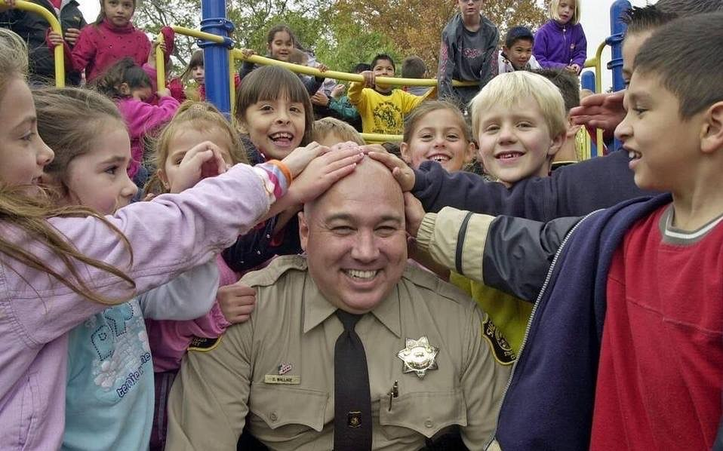
DW61 Foundation, Inc. Wants to spread the message of hope and compassion. We believe that a single action can make a difference in the community, and that collective action can greatly impact the world.

Scholarship Application-APPLICATION DEADLINES IS Friday March 1st, 2024

A Student enrolled in full-time studies that plans to attend a 2- or 4-year degree at an Accredited College or University/Vocational Trade School. Selection will be based upon character, academic, performance, extra-curricular activities and community involvement.
Scholarship will be awarded to the Winner upon written proof that he/she is enrolled in College or Vocational School along with School Schedule.

Requirements for Submission:
Applications must include an application form, two letters of Reference, and a personal Statement describing your Professional/Career goals. You may use a separate paper.

I, understand, If Selected as a Scholarship Award Recipient of the DW61 Foundation, I give the Foundation permission to use my photograph to Congratulate the Winners. This will encourage future students to apply, promote their Social Media pages and help the Foundation for Future Charity Events.

Applicant Signature: _________________________________ Date: _______________________

You may return your application to any of the Following Addresses:
DW61 Foundation PO BOX 792 Hughson, CA 95326
Email: DW61foundation@yahoo.com
Name:_____________________________________________________
Address:____________________________________________________
Email Address:_______________________________________________
Phone Number:______________________________________________
Intended College/Vocational Trade School:________________________________________________
Name of your Current School:___________________________________
Accumulative GPA:________________ Current GPA:___________________

Please submit this form with the Application. Please answer the following questions completely. Any questions not answered will count against the application on the Scoring Sheet.

- What do you want to do after you graduate from college?
- Why did you select this career?
- How will you change the field/industry?
- Where do you see yourself 10 years from now?
- Please write a short autobiography including information about your family, work experience, community involvement, hobbies, spare time activities, and what you hope to do in the future.
- Please include a short summary or personal statement describing your accomplishments and goals.
- List any honors and awards you’ve received.
- List your extra-curricular activities.

Thank you for applying for the DW61 Foundation Scholarship.

